Headers and Footers

Headers and footers are areas in the top and bottom margins of each page in a document.

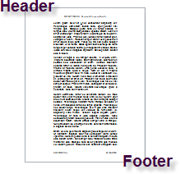

Headers and footers can hold text and graphics - a company logo, the document title or the author's name.

# Insert a header or footer

On the **Insert** tab, in the **Header & Footer group**, click **Header** or **Footer**.

The **Design** tab of the **Header & Footer Tools** section containing several groups of commands appears.

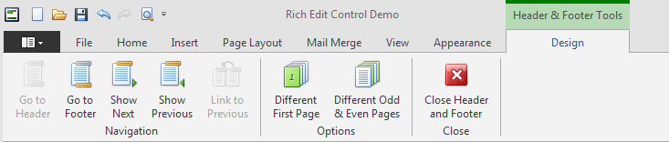

Type text or insert graphics by using the options in the **Insert** tab.

# Make the first page header or footer different from the rest of the pages

On the first page of the document, double click the header or footer area.

Under **Header & Footer Tools**, on the **Design** tab, in the **Options** group, select the **Different First Page** button.

Create a header or footer, or make changes to the existing header or footer, on the first page.

# Make the header or footer different in each section or chapter

If the document contains several sections, you can modify headers and footers so that they display different content for each section. For example, the header may contain the name of a chapter for pages belonging to each chapter.

Starting at the beginning of the document, click in the first section for which you want to vary the header or footer.

On the **Insert** tab, in the **Header & Footer** group, click **Header** or **Footer**.

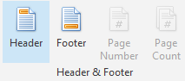The **Design** tab appears. In the **Navigation** group, click **Link to Previous** to break the connection between the header or footer in this section and the previous section.

Change the existing header or footer, or create a new header or footer for this section. In the **Navigation** group of the **Design** tab click **Show next** to navigate to the header or footer of the next section.

On the **Headers & Footers** tab, in the **Navigation** group, click **Link to Previous** to break the connection between the header or footer in this section and the previous section.

Change the existing header or footer, or create a new header or footer for this section.

Repeat the previous three steps for all of the sections in the document.